***BSIT Part-IV Morning***

**Network Management and Security ITEC-616**

**Assignment: 1**

* **Ceaser cipher with key size 4**

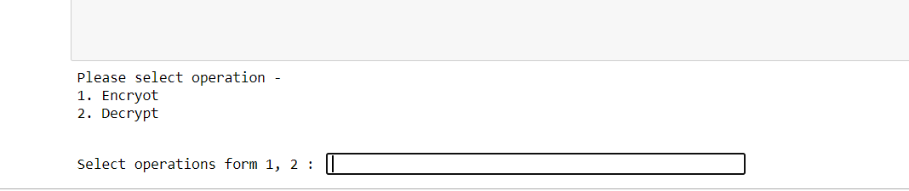**Step 1:**

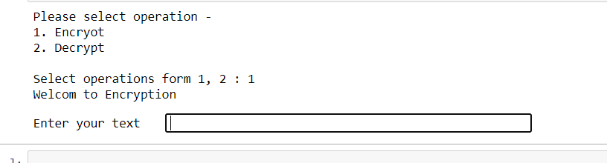**Step 2:**

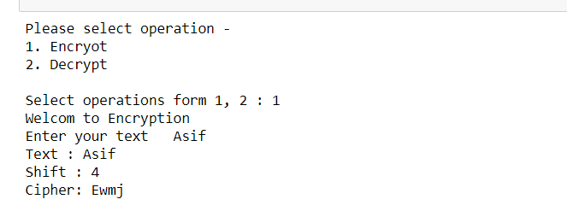**Encrypt:**

**Decrypt:**

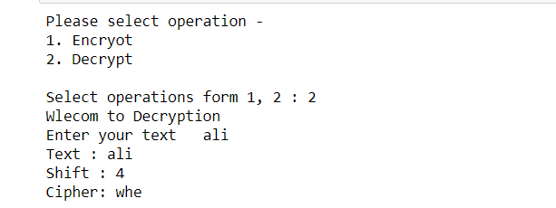

**Code:**

def encrypt(text,s):

result = ""

for i in range(len(text)):

char = text[i]

# Encrypt uppercase characters

if (char.isupper()):

result += chr((ord(char) + s-65) % 26 + 65)

# Encrypt lowercase characters

else:

result += chr((ord(char) + s - 97) % 26 + 97)

return result

def decrypt(text,s):

result = ""

for i in range(len(text)):

char = text[i]

# Encrypt uppercase characters

if (char.isupper()):

result += chr((ord(char) - s-65) % 26 + 65)

# Encrypt lowercase characters

else:

result += chr((ord(char) - s - 97) % 26 + 97)

return result

print("Please select operation -\n" \

"1. Encryot\n" \

"2. Decrypt\n")

select = int(input("Select operations form 1, 2 : "))

if select == 1:

print("Welcom to Encryption")

text = str(input("Enter your text "))

s = 4

print( "Text : " + text)

print ("Shift : " + str(s))

print ("Cipher: " + encrypt(text,s))

elif select == 2:

print("Wlecom to Decryption")

text = str(input("Enter your text "))

s = 4

print( "Text : " + text)

print ("Shift : " + str(s))

print ("Cipher: " + decrypt(text,s))

else:

print("Invalid input")

**GitHubLink:**

[**https://github.com/Asif26/-Network-Management-and-Security--Assignment-1.git**](https://github.com/Asif26/-Network-Management-and-Security--Assignment-1.git)